MYSQL Task

- Retrieve all customers who have placed an order in the last 30 days.
SELECT DISTINCT c.*
FROM customers c
JOIN orders o ON c.id = o.customer_id
WHERE o.order_date >= DATE_SUB(NOW(), INTERVAL 30 DAY);
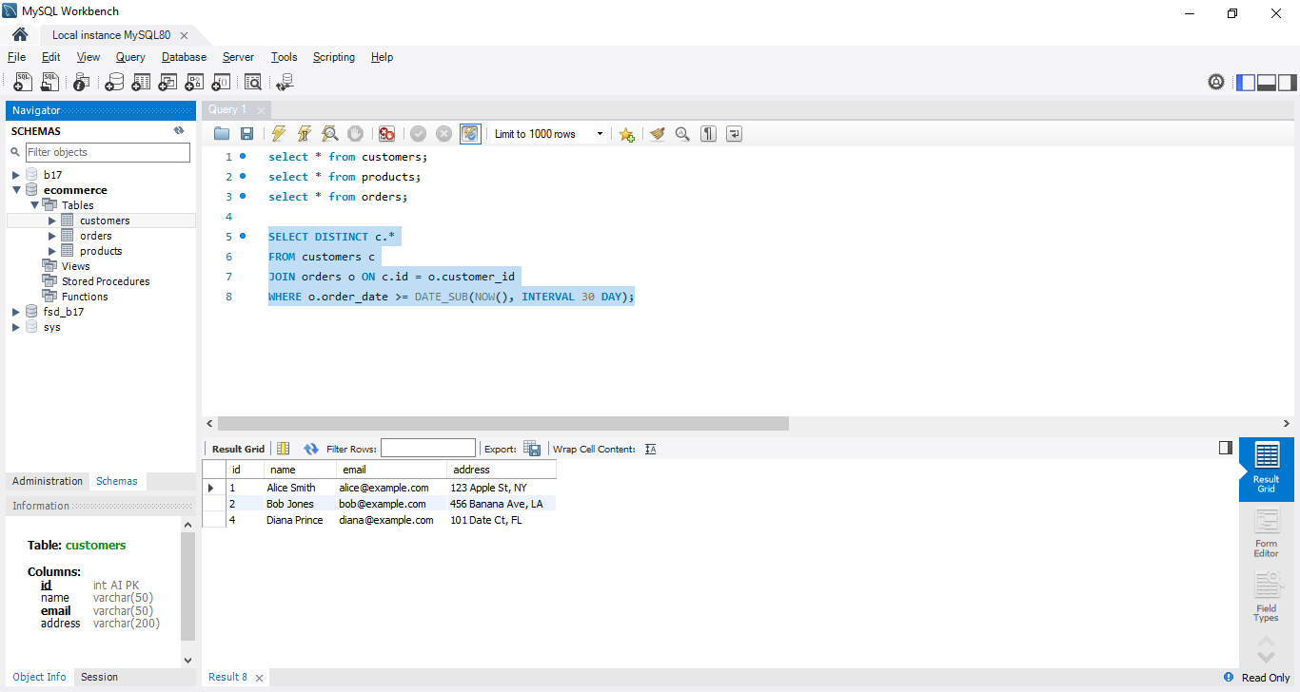

- Get the total amount of all orders placed by each customer.

SELECT c.name, COALESCE(SUM(o.total_amount), 0) AS total_spent FROM customers c LEFT JOIN orders o ON c.id = o.customer_id GROUP BY c.id, c.name;

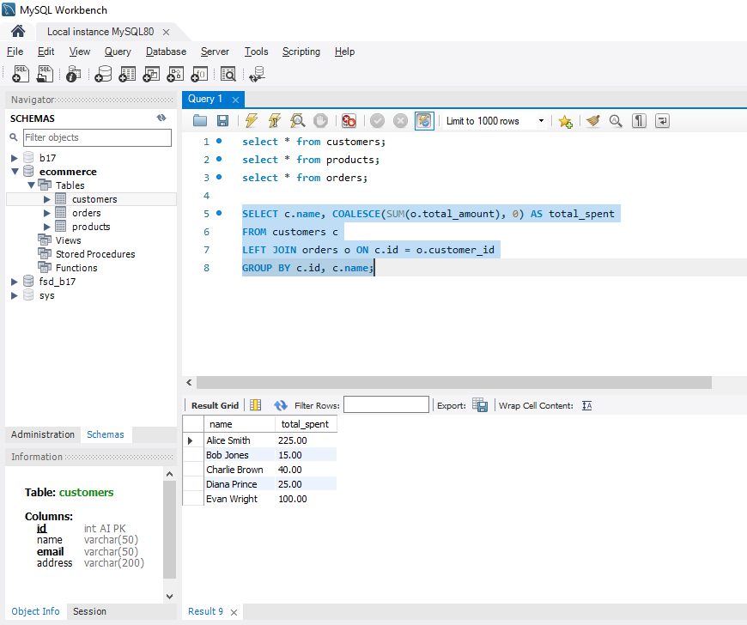

- Update the price of Product C to 45.00.
UPDATE products
SET price = 45.00
WHERE id =3; //name = 'Product C';

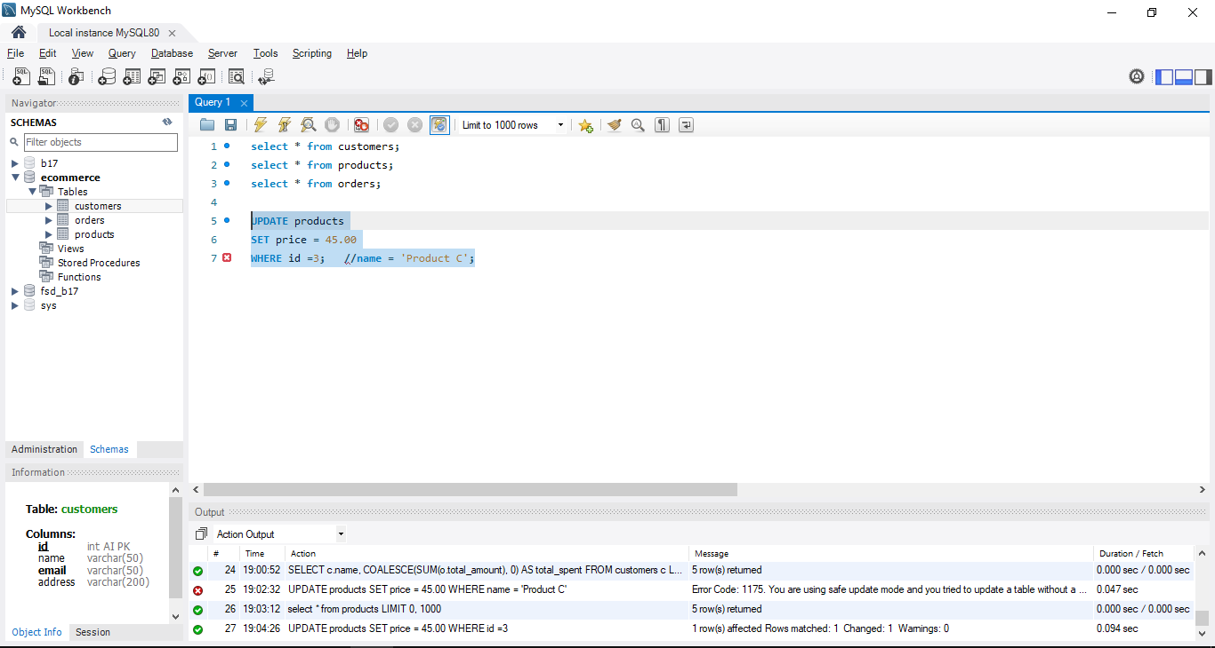

- Add a new column discount to the products table.
Before added new column:
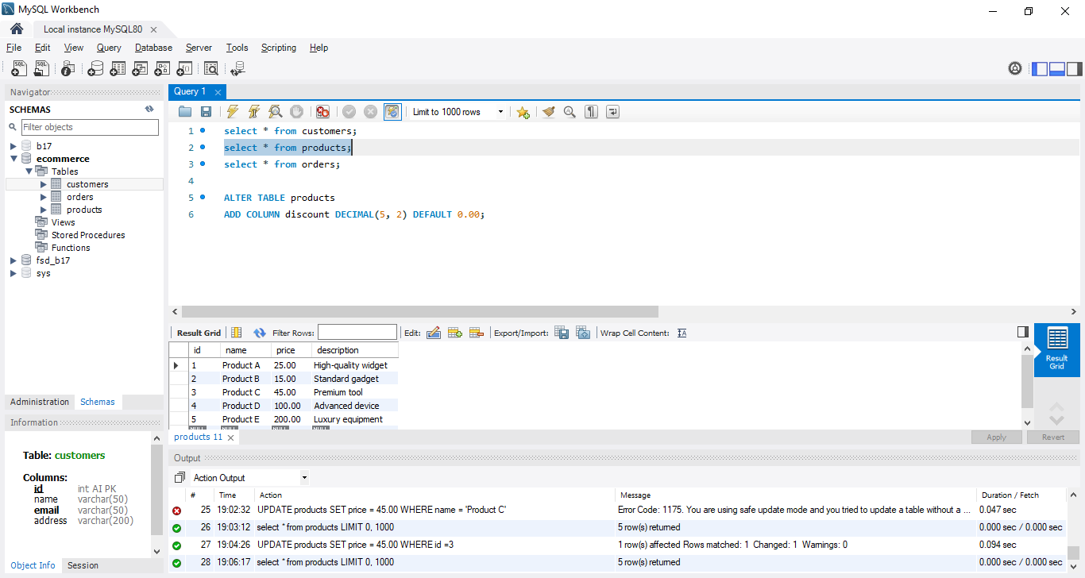

After added NEW Column:
ALTER TABLE products
ADD COLUMN discount DECIMAL(5, 2) DEFAULT 0.00;

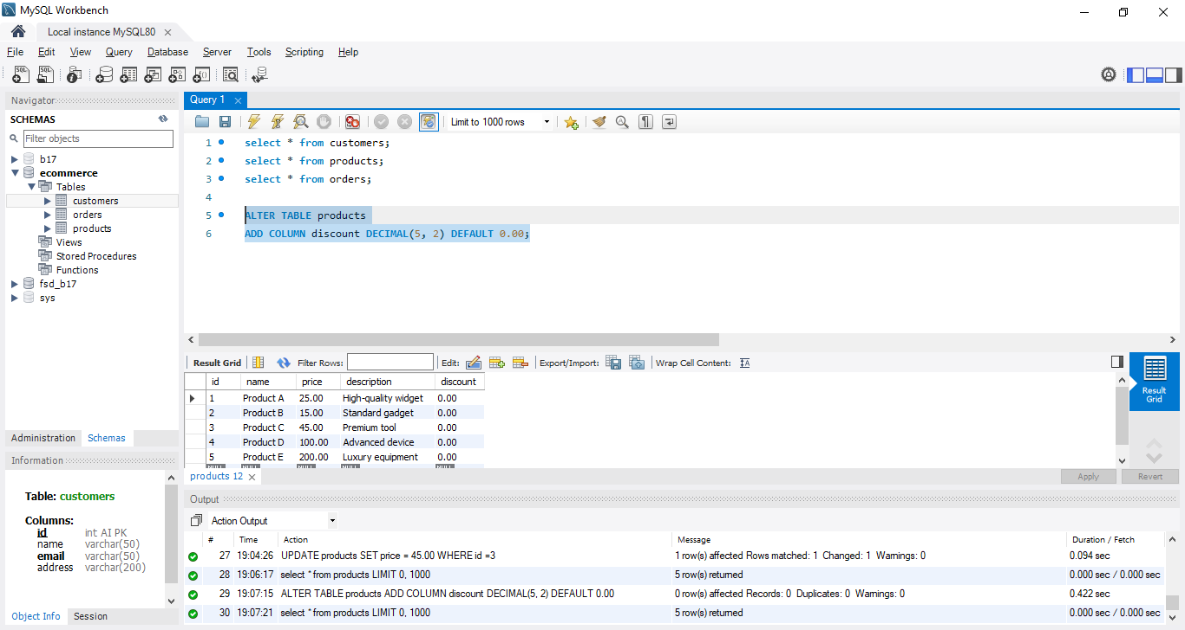

- Retrieve the top 3 products with the highest price.
SELECT *
FROM products
ORDER BY price DESC
LIMIT 3;

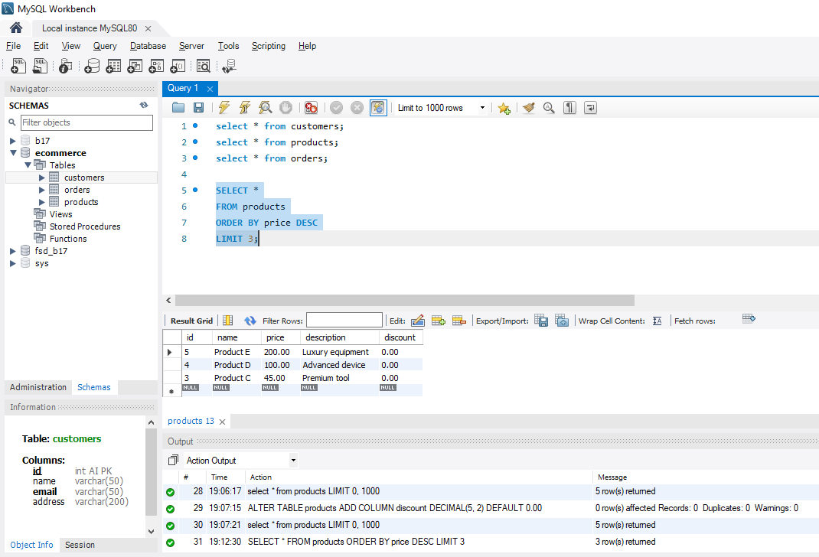

- Get the names of customers who have ordered Product A.
SELECT DISTINCT c.name FROM customers c JOIN orders o ON c.id = o.customer_id JOIN products p ON o.product_id = p.id WHERE p.name = 'Product A';

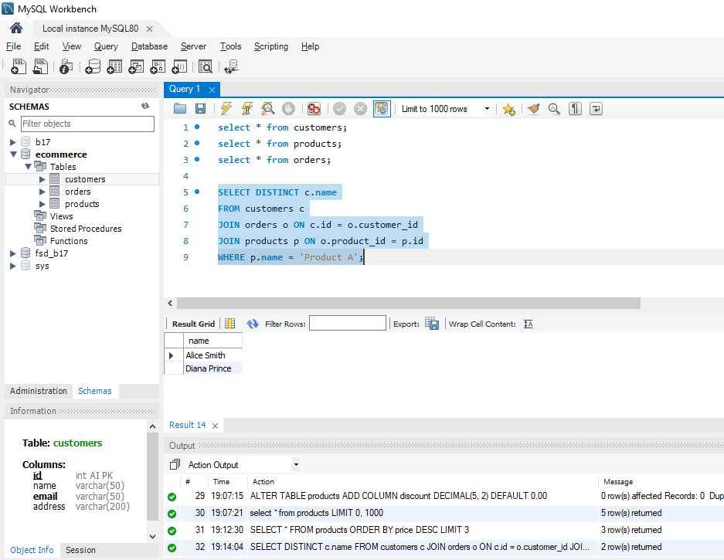

- Join the orders and customers tables to retrieve the customer's name and order date for each order.
SELECT c.name AS customer_name, o.order_date FROM orders o JOIN customers c ON o.customer_id = c.id;

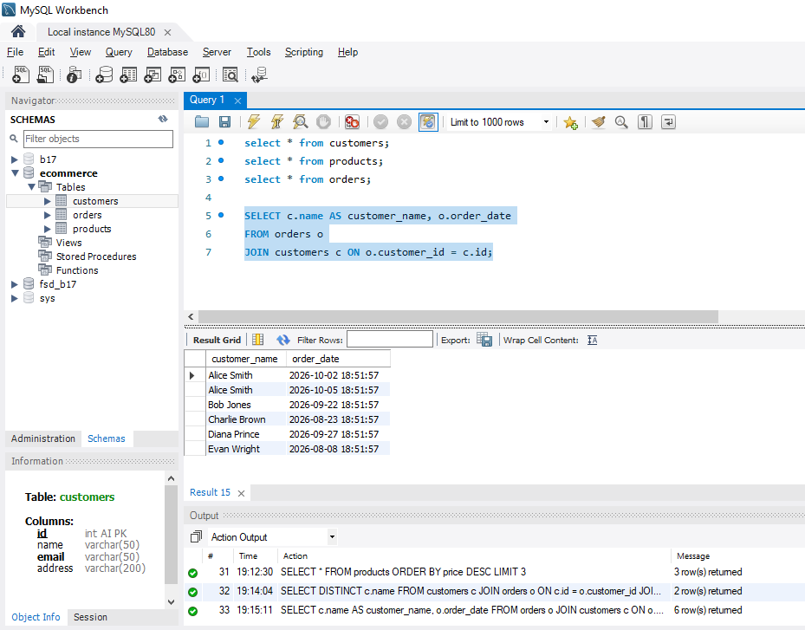

- Retrieve the orders with a total amount greater than 150.00.
SELECT *
FROM orders
WHERE total_amount > 150.00;

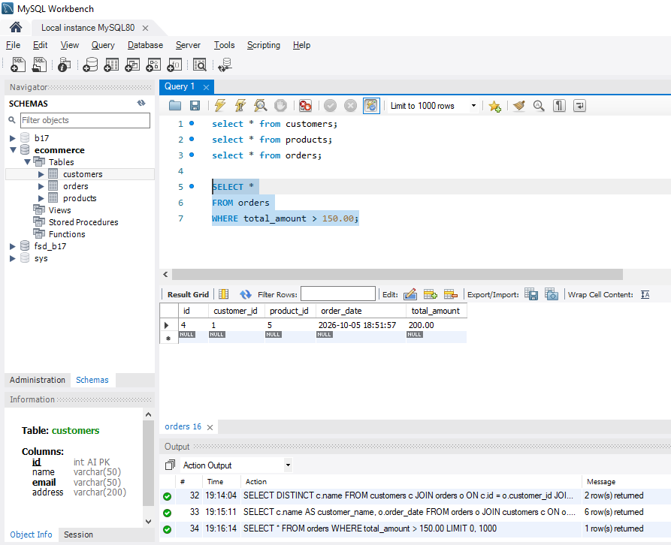

- Normalize the database by creating a separate table for order items and updating the orders table to reference the order_items table.

- CREATE TABLE order_items ( id INT AUTO_INCREMENT PRIMARY KEY, order_id INT, product_id INT, quantity INT DEFAULT 1, price DECIMAL(10, 2), FOREIGN KEY (order_id) REFERENCES orders(id), FOREIGN KEY (product_id) REFERENCES products(id) );

- INSERT INTO order_items (order_id, product_id, quantity, price) SELECT id, product_id, 1, total_amount FROM orders;

- ALTER TABLE orders DROP FOREIGN KEY fk_product; ALTER TABLE orders DROP COLUMN product_id;

- Retrieve the average total of all orders.
SELECT AVG(total_amount) AS average_order_total FROM orders;

